Customer Journey Map
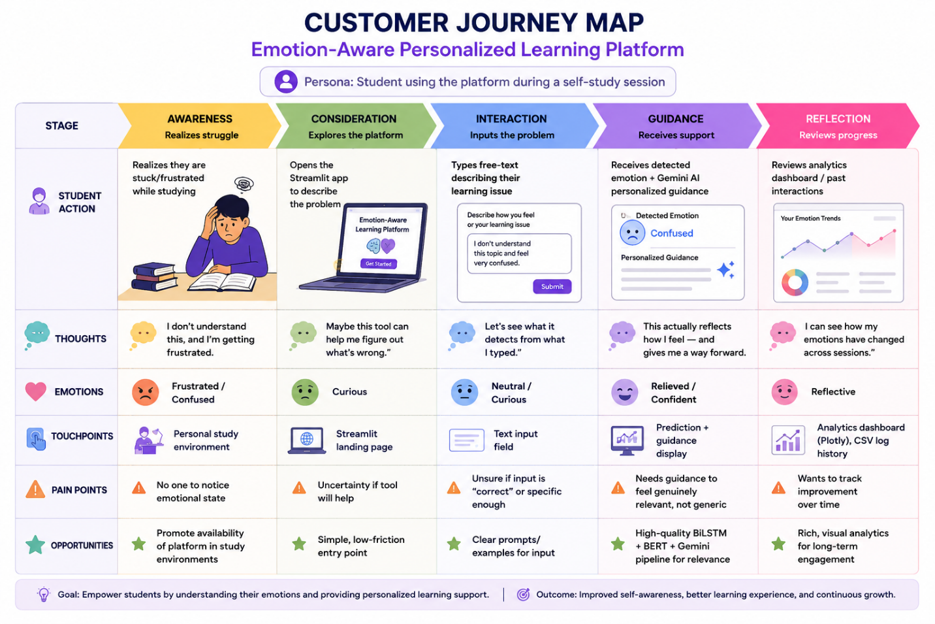
Project: Emotion-Aware Personalized Learning Platform Persona: Student using the platform during a self-study session
Stage | Awareness | Consideration | Interaction | Guidance | Reflection
Student Action | Realizes they are stuck/frustrated while studying | Opens the Streamlit app to describe the problem | Types free-text describing their learning issue | Receives detected emotion + Gemini AI personalized guidance | Reviews analytics dashboard / past interactions
Thoughts | “I don’t understand this, and I’m getting frustrated.” | “Maybe this tool can help me figure out what’s wrong.” | “Let’s see what it detects from what I typed.” | “This actually reflects how I feel — and gives me a way forward.” | “I can see how my emotions have changed across sessions.”
Emotions | Frustrated / Confused | Curious | Neutral / Curious | Relieved / Confident | Reflective
Touchpoints | Personal study environment | Streamlit landing page | Text input field | Prediction + guidance display | Analytics dashboard (Plotly), CSV log history
Pain Points | No one to notice emotional state | Uncertainty if tool will help | Unsure if input is “correct” or specific enough | Needs guidance to feel genuinely relevant, not generic | Wants to track improvement over time
Opportunities | Promote availability of platform in study environments | Simple, low-friction entry point | Clear prompts/examples for input | High-quality BiLSTM + BERT + Gemini pipeline for relevance | Rich, visual analytics for long-term engagement

